NEPAL COLLEGE OF INFORMATION TECHNOLOGY
Balkumari, Lalitpur
Affiliated to Pokhara University

LAB REPORT FOR EMBEDDED SYSTEMS


LAB REPORT 9: VHDL CODE FOR FLIP FLOP

Submitted by: Submitted to:
Name: Arpan Adhikari Er. Simanta Kasaju Roll No.: 231309
BE-CE (5th SEM)

S. N | LAB TOPIC | DATE | REMARKS
1. | VHDL Code (OR & AND Gate) | 20th Nov, 2025
2. | VHDL Code (OR & NOT Gate) using testbench | 23rd Nov
3. | Universal Gates and Special Gates | 30th Nov
4. | VHDL Code for Adder | 7th Dec
5. | VHDL Code for Subtractor | 14th Dec
6. | VHDL Code for Multiplexer | 21st Dec
7. | VHDL Code for De-Multiplexer | 4th Jan,  2026
8. | VHDL Code for Decoder and Encoder | 18th Jan
9. | VHDL Code for Flip Flop | 25th Jan

LAB 9: VHDL CODE FOR FLIP FLOP

Theory
A flip-flop is a basic sequential logic circuit capable of storing one bit of binary information. Unlike combinational circuits, flip-flops have memory, meaning their output depends on the present input and the previous state. Flip-flops are triggered by a clock signal and are widely used in registers, counters, and memory elements.

SR (Set-Reset) Flip-Flop

Theory
The SR flip-flop has two inputs: S (Set) and R (Reset), along with outputs Q and Q̅.
- When S = 1, the output is set to 1
- When R = 1, the output is reset to 0
- When both inputs are 0, the output remains unchanged
- When both inputs are 1, the condition is invalid

Truth Table (SR Flip-Flop)
S | R | Q (Next State)
0 | 0 | No change
0 | 1 | 0
1 | 0 | 1
1 | 1 | Invalid

Limitation
The invalid condition (S = R = 1) is a major drawback of the SR flip-flop.

JK Flip-Flop

Theory
The JK flip-flop is an improved version of the SR flip-flop that eliminates the invalid state. It has two inputs: J and K.
- When both inputs are 0, the output remains unchanged
- When J = 1 and K = 0, the output is set
- When J = 0 and K = 1, the output is reset
- When J = K = 1, the output toggles

Truth Table (JK Flip-Flop)
J | K | Q (Next State)
0 | 0 | No change
0 | 1 | 0
1 | 0 | 1
1 | 1 | Toggle

Advantage
The JK flip-flop has no invalid condition and is widely used in counters and registers.

D (Data or Delay) Flip-Flop

Theory
The D flip-flop has a single input D and eliminates ambiguity by ensuring that the output follows the input at the clock edge.
- The output Q takes the value of D when the clock is triggered
- It is commonly used for data storage and registers

Truth Table (D Flip-Flop)
D | Q (Next State)
0 | 0
1 | 1

Advantage
Simple operation and no invalid state.

T (Toggle) Flip-Flop

Theory
The T flip-flop is obtained from a JK flip-flop by tying J and K together.
- When T = 0, the output remains unchanged
- When T = 1, the output toggles
It is mainly used in binary counters.

Truth Table (T Flip-Flop)
T | Q (Next State)
0 | No change
1 | Toggle

Master-Slave Flip-Flop

Theory
A Master-Slave flip-flop consists of two flip-flops connected in series to eliminate race-around condition.
- The master responds during the first half of the clock
- The slave responds during the second half
This ensures stable output changes.

Comparison of Flip-Flops
Flip-Flop | Inputs | Special Feature
SR | S, R | Simple but has invalid state
JK | J, K | No invalid state
D | D | Output follows input
T | T | Toggles output
Master-Slave | Varies | Eliminates race condition

Applications of Flip-Flops
- Registers
- Counters
- Memory units
- Shift registers
- Timing and control circuits

SR FLIP FLOP

BEHAVIORAL:

library IEEE;
use IEEE.std_logic_1164.all;

entity arp_flipflop is
port(
S,R, Clk : in Std_logic;
Q, Qn : out Std_logic
);
end arp_flipflop;

architecture arch_arp of arp_flipflop is
signal preQ : Std_logic := '0';

begin
process(Clk, S, R)
begin
if (Clk = '1') then
if(S='0' and R='0') then
preQ <= preQ;
elsif (S='0' and R='1') then
preQ <= '0';
elsif (S='1' and R='0') then
preQ <= '1';
else
preQ <= 'X';
end if;
end if;
end process;

Q <= preQ;
Qn <= not preQ;

end arch_arp;

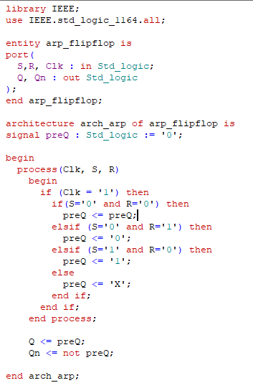

TESTBENCH:

library IEEE;
use IEEE.std_logic_1164.all;

entity test_flipflop is
end test_flipflop;

architecture test_flipflop_arch of test_flipflop is
component arp_flipflop is
port(
S,R, Clk : in Std_logic;
Q, Qn : out Std_logic
);
end component;

signal S, R, Clk : Std_logic;
signal Q, Qn : Std_logic;

begin
UUT: arp_flipflop port map
(
S => S,
R => R,
Clk => Clk,
Q => Q,
Qn => Qn
);

clk_process : process
begin
Clk <= '0';
wait for 0 ps;
Clk <= '1';
wait for 5 ps;
end process;

stim_proc : process
begin
S <= '0'; R <= '0';
wait for 100 ps;
S <= '0'; R <= '1';
wait for 100 ps;
S <= '1'; R <= '0';
wait for 100 ps;
S <= '1'; R <= '1';
wait for 100 ps;
end process;

end test_flipflop_arch;

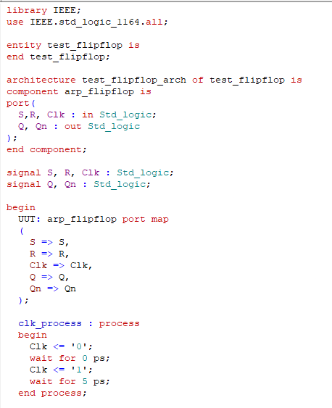

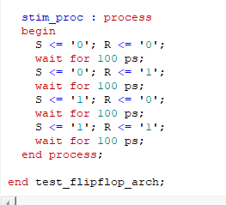

WAVEFORM:

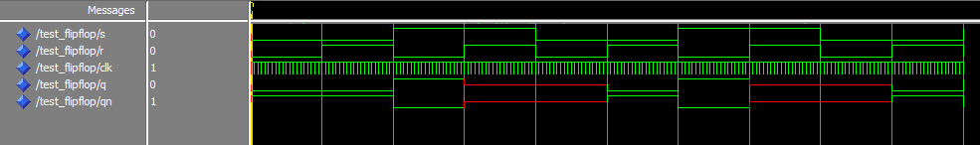

JK FLIP FLOP

BEHAVIORAL:

library IEEE;
use IEEE.std_logic_1164.all;

entity arp_flipflop is
port(
S,R, Clk : in Std_logic;
Q, Qn : out Std_logic
);
end arp_flipflop;

architecture arch_arp of arp_flipflop is
signal preQ : Std_logic := '0';

begin
process(Clk, S, R)
begin
if (Clk = '1') then
if(S='0' and R='0') then
preQ <= preQ;
elsif (S='0' and R='1') then
preQ <= '0';
elsif (S='1' and R='0') then
preQ <= '1';
else
preQ <= not preQ;
end if;
end if;
end process;

Q <= preQ;
Qn <= not preQ;

end arch_arp;

TESTBENCH:

library IEEE;
use IEEE.std_logic_1164.all;

entity test_flipflop is
end test_flipflop;

architecture test_flipflop_arch of test_flipflop is
component arp_flipflop is
port(
S,R, Clk : in Std_logic;
Q, Qn : out Std_logic
);
end component;

signal S, R, Clk : Std_logic;
signal Q, Qn : Std_logic;

begin
UUT: arp_flipflop port map
(
S => S,
R => R,
Clk => Clk,
Q => Q,
Qn => Qn
);

clk_process : process
begin
Clk <= '0';
wait for 0 ps;
Clk <= '1';
wait for 5 ps;
end process;

stim_proc : process
begin
S <= '0'; R <= '0';
wait for 100 ps;
S <= '0'; R <= '1';
wait for 100 ps;
S <= '1'; R <= '0';
wait for 100 ps;
S <= '1'; R <= '1';
wait for 100 ps;
end process;

end test_flipflop_arch;

D FLIP-FLOP

BEHAVIORAL
library IEEE;
use IEEE.std_logic_1164.all;

entity arp_dflipflop is
port(
D, Clk : in std_logic;
Q, Qn : out std_logic
);
end arp_dflipflop;

architecture arch_arp of arp_dflipflop is
signal preQ : std_logic := '0';
begin
process(Clk, D)
begin
if (Clk = '1') then
preQ <= D;
end if;
end process;

Q <= preQ;
Qn <= not preQ;
end arch_arp;

TESTBENCH
library IEEE;
use IEEE.std_logic_1164.all;

entity test_dflipflop is
end test_dflipflop;

architecture test_arch of test_dflipflop is
component arp_dflipflop
port(
D, Clk : in std_logic;
Q, Qn : out std_logic
);
end component;

signal D, Clk : std_logic;
signal Q, Qn : std_logic;

begin
UUT: arp_dflipflop port map (D => D, Clk => Clk, Q => Q, Qn => Qn);

clk_process : process
begin
Clk <= '0'; wait for 5 ps;
Clk <= '1'; wait for 5 ps;
end process;

stim_proc : process
begin
D <= '0'; wait for 100 ps;
D <= '1'; wait for 100 ps;
D <= '0'; wait for 100 ps;
end process;
end test_arch;

T FLIP-FLOP

BEHAVIORAL
library IEEE;
use IEEE.std_logic_1164.all;

entity arp_tflipflop is
port(
T, Clk : in std_logic;
Q, Qn : out std_logic
);
end arp_tflipflop;

architecture arch_arp of arp_tflipflop is
signal preQ : std_logic := '0';
begin
process(Clk, T)
begin
if (Clk = '1') then
if (T = '1') then
preQ <= not preQ;
else
preQ <= preQ;
end if;
end if;
end process;

Q <= preQ;
Qn <= not preQ;
end arch_arp;

TESTBENCH
library IEEE;
use IEEE.std_logic_1164.all;

entity test_tflipflop is
end test_tflipflop;

architecture test_arch of test_tflipflop is
component arp_tflipflop
port(
T, Clk : in std_logic;
Q, Qn : out std_logic
);
end component;

signal T, Clk : std_logic;
signal Q, Qn : std_logic;

begin
UUT: arp_tflipflop port map (T => T, Clk => Clk, Q => Q, Qn => Qn);

clk_process : process
begin
Clk <= '0'; wait for 5 ps;
Clk <= '1'; wait for 5 ps;
end process;

stim_proc : process
begin
T <= '0'; wait for 100 ps;
T <= '1'; wait for 100 ps;
T <= '1'; wait for 100 ps;
T <= '0'; wait for 100 ps;
end process;
end test_arch;

Result
The SR, JK, D, and T flip-flops were successfully designed and simulated using VHDL behavioral modeling. The output waveforms obtained from the simulations matched the expected truth tables. Each flip-flop responded correctly to the clock signal, and the stored output changed according to the applied input conditions.

Conclusion
This experiment successfully demonstrated the design and operation of basic sequential circuits using VHDL. The behavior of different flip-flops and their role in data storage and state control were clearly understood. The experiment confirmed that VHDL is an effective tool for modeling, simulating, and verifying flip-flop based digital circuits.

